**Warande Sounds - 2017 no. 1**

**Your electronic front door lock**   
As of January 1st the contract for the maintenance of the DOM Protector® (yearly battery change in the door cylinder) and troubleshooting to your electronic front door lock has been granted to a new company, namely **WIEK DE LAAT BEVEILIGING.**  For urgent problems outside the business hours of the vb&t service desk you can contact their 24/7 number directly: **073 5492773**. The old stickers on various access doors with the number of Lock-It Slotambulance will be replaced. It is foreseen to hold a number of pre-programmed DOM Protectors at WIEK DE LAAT in reserve so that, if required, immediately a new DOM Protector® can be placed (e.g. at the cyclists’ entrance next to the roller door of the parking garage) instead of a temporarily mechanical lock with a limited number of keys.

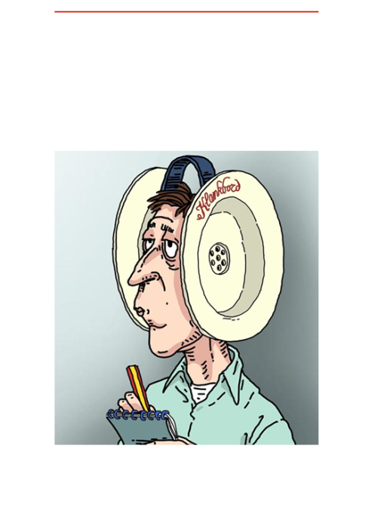

**Warande Sounds** communicate concise news items of Soundboard Warande.

Publication is irregularly based upon information provision needs.

Published numbers will be archived on the website.

www.  
klankbordwarande.  
jouwweb.nl

www.  
zuiderparkbc.  
jouwweb.nl

For your information: WIEK DE LAAT is the company that also will be called upon by the company MANSFELD (24-hour service electrical faults including parking garage roller door) for specialized expertise to solve roller door malfunctions and outages.

**Wheelchair-friendly entrances**   
It is expected that in the course of February by T&G (the company that is also in charge of the maintenance of the green) the pavement for the three entrance halls of Park will be gradually elevated up to the height of the metal sill of the entrance doors South, Middle and North. At the same time three parking lots in front of Warande (1 on either sides of the tree in front of the entrance Middle; 1 being the last parking lot at the entrance South ) will be partially repaved as they currently form due to the upcoming underground roots a serious risk for stumbling over it.

The plan is to obtain from vb&t short before the planned start date of work some more information in order to provide you through our internal Warande communications with details like the dates, duration and impact of this re-pavement work .

**Follow-up annual meeting residents**   
Approximately twenty senior residents attended the annual meeting of Klankbord Warande at the end of last year. The round table discussion which was conducted during this meeting reconfirmed the requirement for lockable elevator porches in the parking garage. This gap, in our view, in the access security of the complex has been submitted already once, namely end of 2014, to Archipel as part of a security report (document stored on the website but available in Dutch language only ) but has as yet not been acknowledged by Archipel in order to start up a necessary project for starting closing this security flaw. This security theme will be again put on the agenda by Klankbord Warande for discussion with vb&t during the biannual meetings this year. Also, on the request of the residents meeting, the requirement for a simple camera surveillance at both the roller door garage as the three entrance halls will be tabled as an agenda point.

**Outstanding repair swing door elevator porch North parking garage.**   
A back report of the Assa Abloy technician in November seeking approval for placing a new motor in the Besam® swing door operator apparently slipped to the attention of vb&t. Vb&t will follow up this soonest in order to restore the function of this automatic door.