You will be aware that, in addition to the monthly rent, you are paying a monthly advance (70 euro) for the costs pertaining to common services and common installations, the so called service costs. Final settlement of these advance payments occurs usually within 6 months after the passed calendar year. The service costs bill for 2015 is now awaiting formal approval of Archipel and likely to be sent to each tenant in less than 1 or 2 weeks.

Prior to that, Klankbord Warande received a copy to comment upon or raise questions, though as a tenant committee we have no formal role in the approval process. As a result of the reviewing process by Klankbord Warande you will find in the below table a cost comparison between 2015 and 2014 with brief explanatory notes underneath. Overall the service costs where below the planned budget which implies you will receive money back. The advanced payment will remain unchanged for this year. If you have been renting for the entire year 2015, you may expect to get around 125 euro reimbursed. Some more related details, amongst other the estimated monthly savings produced by the introduced lighting management , are posted on the website page [algemene verlichting](http://klankbordwarande.jouwweb.nl/algemene-verlichting), however this page is available in Dutch language only.

|  |  |  |  |  |  |
| --- | --- | --- | --- | --- | --- |
| **COMPARISON OF COSTS 2015 - 2014. Draft status pending final approval** | | | | | |
| Group | description | year 2015 | year 2014 | increase/decrease | % |
| 30 | electricity costs | € 12.338 | € 12.365 | -€ 27 | -0,2% |
| 40 | cleaning contracts | € 10.950 | € 10.839 | € 111 | 1% |
| 51 | central heating system | € 1.186 | € 2.035 | -€ 849 | -42% |
| 53 | elevators | **€ 2.701** | € 2.476 | € 225 | 9% |
| 58 | replacement of light bulbs | € 237 | € 1.169 | -€ 932 | -80% |
| 60 | installations/provisions | € 2.960 | € 2.929 | € 31 | 1% |
| 70 | glass insurance | € 542 | € 542 | € 0 | 0% |
| **PROVISIONAL TOTAL AMOUNT** | | **€ 30.915** | **€ 32.354** | **-€ 1.439** | **-4%** |
|  |  |  |  |  | decrease |
|  |  |  |  |  | increase |

1% increase in **group 40** (cleaning contracts) and in **group 60** (24 hour service Lock-It and Mansfeld) within yearly indexation of the annual contracts.

Small decrease in **group 30** (electricity costs) in spite of an increased electricity price due to not replacing of a large number of expired light bulbs in 2015 within the context of the by end 2015 introduced light management .

**Group 51**: Structural decrease with effect from 2015 due to changed policy. Before 2015 it was common practice on the market to charge tenants with 35% of the costs for maintenance contracts for heating systems with a 24 hour service component. The authoritative committee for tenant issues in the Netherlands has decided to limit the costs for tenants down to 20% of the sum for central heating system 24 hour service contracts from 2015 onwards.

**Group 53**: The amount stated in the table is a provisional figure which will be reduced with the costs paid in 2015 for periodical certification of the elevators. These latter costs are not chargeable to tenants but are 100% costs for the owner of the building. It is expected that these costs amount to approximately 200 euro which after subtraction will neutralize the difference in costs with 2014.

Achieved savings in **group 58** (replacement of bulbs) due to by end of 2015 introduced light management amongst other based on the principle of self-replacement and self-repair if possible by a small tenants committee working group.

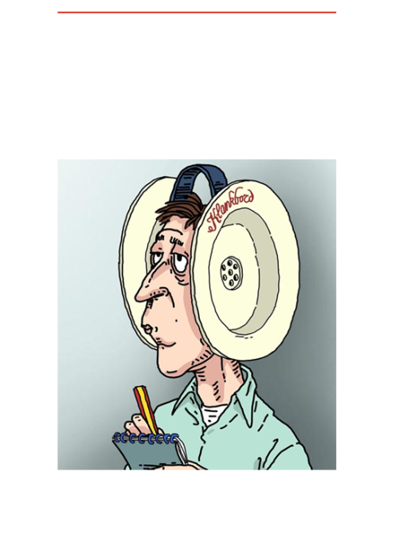

**Warande Sounds** communicate concise new items of Soundboard Warande.

Publication is irregularly based upon information provision needs

Published numbers will be archived on the website.

www.  
klankbordwarande.  
jouwweb.nl

www.  
zuiderparkbc.  
jouwweb.nl

**Warande Sounds - 2016 no. 2**