Website: www.klankbordwarande.jouwweb.nl

**Cooperation with the tenants’ committee (TC) Leilinde**TC Leilinde and Soundboard Warande have a joined section for organizing social activities. Currently the manning of this joined section is entirely provided by Leilinde. Which Warande resident (male or female) would have time and ambition to augment this section, be it now or in due time, or take place in a future working group? For more information, contact coordinator Soundboard Warande.

For all not typically building related issues both tenants’ committees work closely together and act as one overarching committee in negotiating and advocating the collective interests with the landlord. One common voice will provide more chance to succeed!

The intent is to include in the course of 2017 also in some form the tenants of the two residential towers in this emerging tenants’ cooperation platform. An initial meeting with Woonbedrijf (the landlord for those towers) to discuss the possibilities is planned late 2016.

.

**Annoyance dog shit**Around 4 April prohibition signs against dog shit will be placed by T&G (in charge of the maintenance of the green/lawns and vegetation on Zuiderpark) along the lawn in front of Warande. Recently some self-made signs were attached at the pillars of Warande south with the friendly request to all passing dog owners to keep the sidewalk (corner Ruloffsweg) free from dog poop.

Meanwhile it became clear, though not surprisingly, that this annoyance is not limited to the Warande area but is experienced all over the Zuiderpark area for reasons of (some) dog owners not cleaning up after their dog. It is assessed that this kind of annoyance will increase once the two residential towers will be fully occupied unless structural measures will be implemented by the area owner (Archipel) to contain this problem. A joint Warande & Leilinde letter will be sent to Archipel no later than April to address this problem and outline the requirements for structural measures. As part of these measures the provision of a fenced dog toilet area on Zuiderpark is deemed crucial and a necessity to get this problem under control and where possible to reduce the annoyance.

**Door mats entry halls elevators parking garage**Early week 13 ( likely on Tuesday 29 March) the concrete floors of the entry halls to the elevators in the parking garage will be fully carpeted. A one piece door mat will replace the various make-shift solutions by (former?) residents who placed on the floor of this elevator hall their own mats and carpets. Residents from the north side who like to re-use their red carpets currently laying in their entrance hall, are kindly asked to remove these before Tuesdays 29 March.

**Warande Sounds - 2016 no. 1**

Contact: klankbordwarande@gmail.com

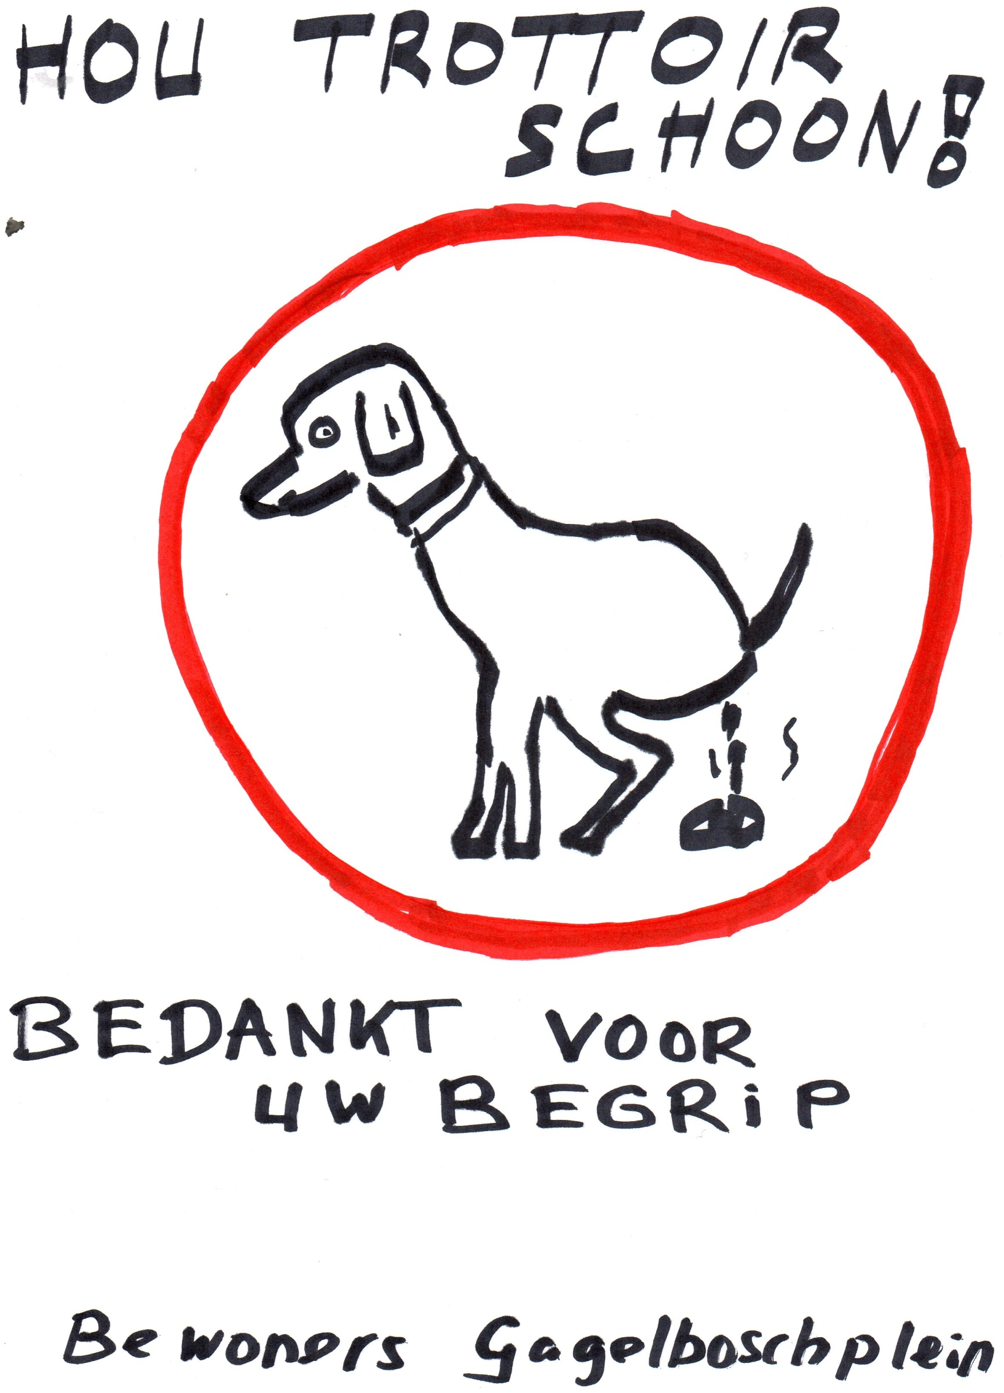

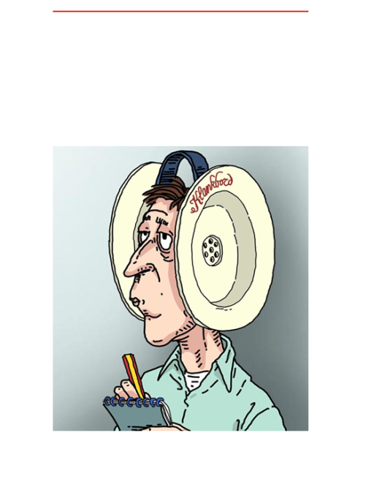

**Warande Sounds** communicate concise new items of Soundboard Warande.

Publication is irregularly based upon information provision needs

Published numbers will be archived on the website.