In this issue you will be informed briefly about implementation of two major projects. In case of any questions, you can refer to coordinator Soundboard Warande.

**Warande Sounds - 2017 no.3**

**Lockable elevator porches in the parking garage**   
This project, which you have been earlier informed upon in previous issues of the Warande Sounds, has now been approved by Archipel (the owner) and installation of the tag readers and other required changes to the automatic swing doors will take place 30 and 31 August. Realisation of this project will be a major improvement in entrance security; for entering the elevator from the parking garage you will have to use your electronic key/tag.

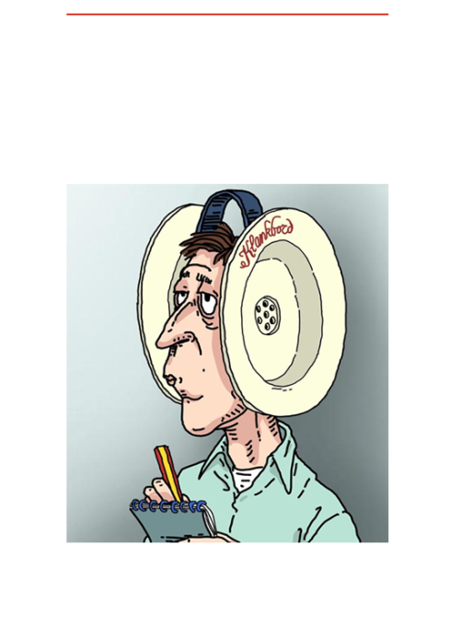

**Warande Sounds** communicate concise news items of Soundboard Warande.

Publication is irregularly based upon information provision needs.

Published numbers will be archived on the website.

www.  
klankbordwarande.  
jouwweb.nl

www.  
zuiderparkbc.  
jouwweb.nl

**Project PowerSwing**  
This is a new project resulting from a very recently submitted user requirement which was discussed on location with our landlord vb&t on August 3rd.  In particular those who frequently use their bike will look forward to implementation of this project. It entails the installation of an automatic swing door operator connected to a tag reader similar to the automatic swing doors at the three main entrances of the building. See also below pictures.

Making use of the window of opportunity offered by the implementation phase of the lockable elevator porches project (the same main companies are involved and cost-savings can be achieved by parallel implementation of both projects), vb&t technical management has worked the last days very hard in order to ensure this project can be finished by the end of August also.

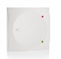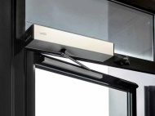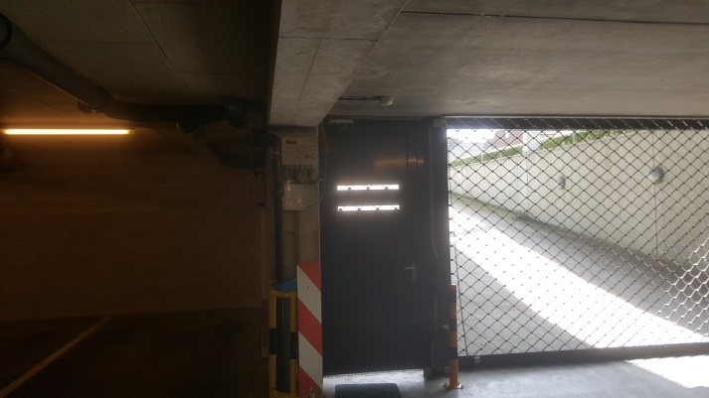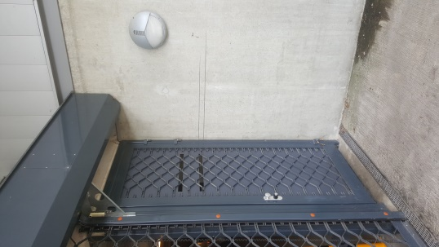

button

tag reader

*PowerSwing*