In this issue you will be informed briefly about several ongoing projects. In case you have any questions, you can refer to coordinator Soundboard Warande.

**Warande Sounds - 2017 no. 2**

**Lockable elevator porches in the parking garage**   
For more background see Warande Sounds 2017/1. A technical study has started to equip the doors of the elevator porches with a card reader in order to open the door with your Dom transponder (your electronic key) upon entering from the parking garage. Dependent on the costs this project might be approved by Archipel for implementation still this year.

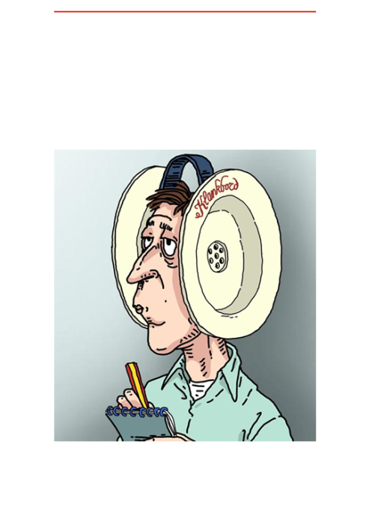

**Warande Sounds** communicate concise news items of Soundboard Warande.

Publication is irregularly based upon information provision needs.

Published numbers will be archived on the website.

www.  
klankbordwarande.  
jouwweb.nl

www.  
zuiderparkbc.  
jouwweb.nl

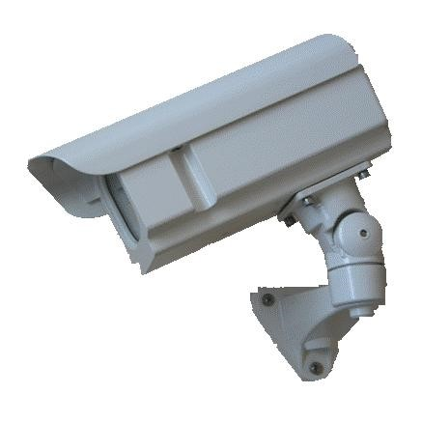**Camera pointed at entrance parking garage**  
The ambition for the future is a camera surveillance system including both the three entrance halls and the parking garage entrance. For the near term this requirement has not been endorsed by Archipel however we got green light to reinstall a similar type of outdoor camera which was in place back in 2010/2011 (until stolen) at the parking garage entrance. Though a model meanwhile become rather obsolete and lacking external digital recording, in consultation with vb&t it has been agreed to nonetheless install such a camera (see picture) in view of its preventive function. It is expected that the camera will be installed no later than July.

**Safe driving away from parking place 26**  
Parking place 26 is situated immediately right in the corner upon entering the parking garage. Driving away from this place or manoeuvring for parking is challenging while risking, due to a bad view, a collision with a car or bike entering at the same time. To remediate this unsafe situation a mirror will be placed, expectedly in June/July, opposite this parking place with view on the roller door and bikers’ entrance door.

**Leaking parking garage ceiling off parking place 5 and 6**   
In times of heavy rainfall water is leaking through the parking garage ceiling off the parking places 5 and 6. After a thorough investigation as most likely cause has been determined a couple of blocked vertical drainage pipes from the above ground terrace to the sewage system. A specialized company has been tasked to solve the problem and if proven successful, new ceiling plates will be installed above the affected parking places.