Once a year a tenant association has to convene a meeting for all residents to review its main activities of the past year and to propose future plans and policy. This **annual meeting** will be conducted on **Thursday evening** **December 1st , from 19.30 hr until 22.00 hr in Atrium 2 of Gagelbosch.**

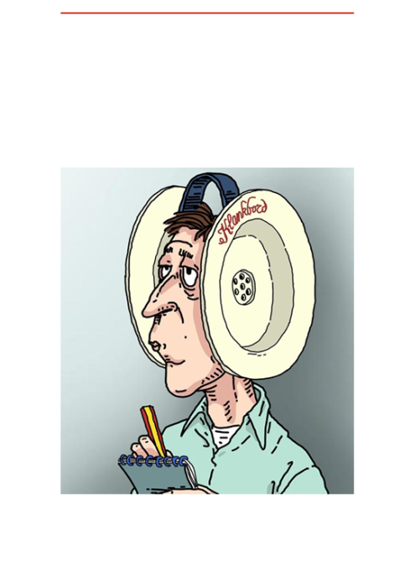

**Warande Sounds** communicate concise news items of Soundboard Warande.

Publication is irregularly based upon information provision needs.

Published numbers will be archived on the website.

www.  
klankbordwarande.  
jouwweb.nl

www.  
zuiderparkbc.  
jouwweb.nl

**Warande Sounds - 2016 no. 3**

Apart from its mandatory character, this meeting will be used for a kind of round table discussion amongst residents. Any subject you would like to see discussed in this platform, you can mail to Klankbord Warande ( no later than 1 week before ) with a short explanatory note as you deem necessary. The idea is that each subject/item will be introduced briefly by coordinator Klankbord Warande including, if applicable, listing options to solve a problem, after which a discussion will follow to see whether there is common ground for a specific solution or way ahead. Should there be more subjects forthcoming for discussion than time will allow that evening, a selection of subjects will be made after consultation of the residents council.

For practical reasons the meeting will be conducted in Dutch language, however bilingual slides will be available and a short introduction and summary can be provided before and after each agenda item. Prior notification of your attendance is not required. To cope with a possible massive attendance, instead of the small conference room the *Atrium* has been reserved as the venue for this annual meeting. Therefore, should you want to join us at the very last minute, you are more than welcome!

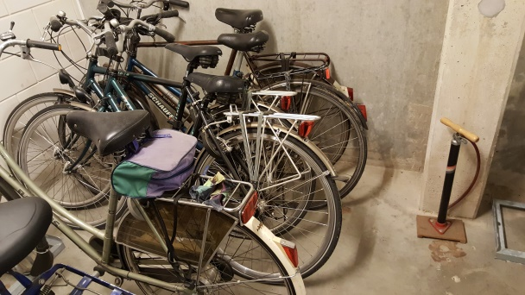

**Common bike storage.**The small corner without racks in the common user bike storage down in the basement, provides some space to place bikes of which is suspected the owner already moved out or otherwise these bikes haven’t been used the last year(s). With effect from December 1st the bikes on the picture will be marked with a vb&t sticker “*Deze fiets zal worden verwijderd!”* (translated: this bike will be removed!) in order to find out whether these bikes are really without owner. In case it is your bike, remove the sticker and notify coordinator Klankbord Warande. Actual disposing of bikes of which no owner could be tracked, will commence after April 1st of next year in order to prevent unnecessary space occupation.   
 In case you have an old but still working bicycle pump, consider ‘donating’ it to Klankbord Warande for common use by all. The idea is to place the pump on a fixed place in the common bike storage as a service to all residents which otherwise would have to store a pump in their own apartment or would have to use a small hand pump on their bike frame instead.